Pizza Sales SQL Queries
A.KPI’S
- Total_Revenue :
SELECT SUM(total_price) AS Total_Revenue FROM pizza_sales

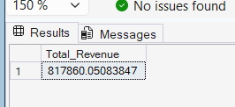

- Average_Order_Value:

select sum(total_price) / count(distinct order_id) as Avg_Order_Value
from pizza_sales
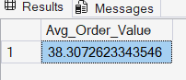

- Total_Pizza_Sold:
select sum(quantity) as Total_Pizza_Sold from pizza_sales

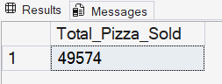

- Total_Orders:
select count(distinct order_id) as Total_orders from pizza_sales

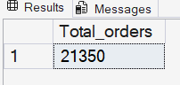

- Average_Pizzas_per_order:

select cast(cast(sum(quantity) as decimal(10,2)) /
cast(count(distinct order_id) as decimal(10,2))
as decimal(10,2)) as Average_pizzas_per_order from pizza_sales
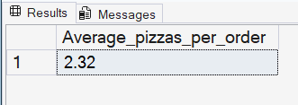

Chart Requirements:
- Daily_Trend_Per_Total_Orders:

select datename(dw,order_date) as order_day, count(distinct order_id) as Total_orders
from pizza_sales group by datename(Dw,order_date)
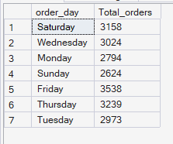

- Montly Trend For Total Orders:

select datename(month,order_date) as month, count(distinct order_id) as Total_Orders
from pizza_sales
group by datename(month,order_date)
order by Total_Orders desc

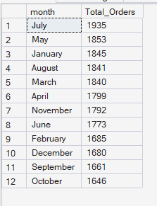

- Percentage of sales by pizza_category:
select pizza_category,cast(sum(total_price) * 100/
(select sum(total_price) from pizza_sales) as decimal(10,2)) as total_percentage
from pizza_sales
group by pizza_category

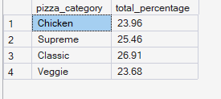

- Percentage of sales by pizza_category in January month:
select pizza_category,sum(total_price) as total_sales,cast(sum(total_price) * 100/
(select sum(total_price) from pizza_sales where month(order_date) = 1)
as decimal(10,2)) as total_percentage
from pizza_sales
where month(order_date) = 1
group by pizza_category

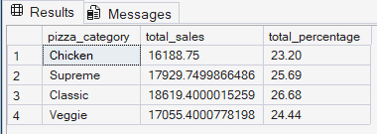

- Percentage of sales by pizza_size :
select pizza_size,cast(sum(total_price) as decimal(10,2)) as total_sales,cast(sum(total_price)* 100 /
(select sum(total_price) from pizza_Sales) as decimal(10,2)) as total_percentage
from pizza_sales
group by pizza_size
order by total_percentage desc

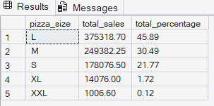

A. Percentage of sales by pizza_size for Quarter:
select pizza_size,cast(sum(total_price) as decimal(10,2)) as total_sales,cast(sum(total_price)* 100 / (select sum(total_price) from pizza_Sales where datepart(quarter, order_date) =1) as decimal(10,2)) as total_percentage from pizza_sales
where datepart(quarter, order_date) =1
group by pizza_size
order by total_percentage desc

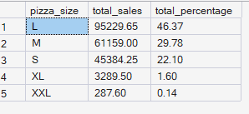

- Total Pizza Sold by Pizza_category :

select pizza_category,sum(quantity) as total_qty_sold from pizza_sales
where month(order_date) = 3
group by pizza_category
order by total_qty_sold desc

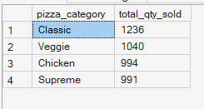

- Top 5 Best Pizzas Revenue :

select top 5 pizza_name , sum(total_price) as Total_Revenue,sum(quantity) as total_qty_sold
from pizza_sales
group by pizza_name
order by Total_Revenue desc

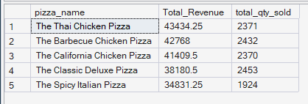

- Bottom 5 pizzas Revenue :

select top 5 pizza_name ,sum(total_price) as Total_Revenue from pizza_sales
group by pizza_name
order by Total_Revenue asc

